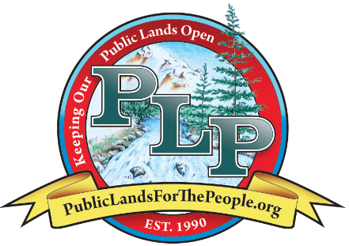

Drawing to be held August 4th 2024

*Leave a message and we will call you back.*

*Last day to order by phone is August 1st, 2024*

**3. Mail a check to: PO Box 1660 InyoKern, CA 93527**

**1. Phone: (844) 757-1990 *Toll Free*or (844) PLP-1990**

[**www.PublicLandsforthePeople.org**](http://www.PublicLandsforthePeople.org)

- **Gold Quartz Specimen donated by Meeting of the Mines/Goldstrike Corp….....$2,500**

- **N. Fork Salmon R. CA Dredge claim donated by** [cerberusminingsolutions@gmail.com](mailto:cerberusminingsolutions@gmail.com) **$6k**

**- 34 Silver Rounds (one ounce each) 34 prizes! PLP…….…………………….… $35 each**

**- 1/4”x24”x48” Rock Harness…** [**www.MoveitCableSystems.com**](http://www.MoveitCableSystems.com) **…………………… $85**

**- Lifetime PLP Membership** [**www.publiclandsforthepeople.org**](http://www.publiclandsforthepeople.org) **..……………….. $1,500**

**- 2 Year ICMJ Subscription** **www.icmj.com** **……………………………………………… $75**

**- (2 prizes) 1 Year Membership to** [**www.ReinkeGoldMining.com**](http://www.ReinkeGoldMining.com) **….…….……$160 Each**

**- Paid admission for 2 people to PLP’s 2024 FallFest .…………………….…………. $150**

**- Garrett AXIOM Pulse Gold Detector** [**www.garrett.com**](http://www.garrett.com) **…...…………….………... $3,995**

**- Thompson II Puffer Drywasher manuf. by Mad Mining.……………..……………..$1,395**

**- PLP Paydirt Gold Bag** [**www.publiclandsforthepeople.org**](http://www.publiclandsforthepeople.org) **……………….……….. $250**

**- Roaring Camp 4 days/ 3 nights donated by** [**www.roaringcampgold.com**](http://www.roaringcampgold.com) **….….. $450**

**- Gold Cube 4-Stack donated by** **www.goldcube.com** **………………………...……... $480**

**- 1 Week Alaska Mining donated by** [**www.SkookumGoldCamp.com**](http://www.SkookumGoldCamp.com) **.……....……. $2,500**

**- 1 Yr MineOperator PureAu Membership** [**www.youtube.com/@mineoperator**](http://www.youtube.com/@mineoperator) **….. $300**

**ORDER YOUR RAFFLE TICKETS TODAY, SUPPORT PLP, AND BE ELIGIBLE TO WIN ONE (OR MORE!) OF THE PRIZES BELOW! MORE PRIZES WILL BE ADDED**

**Still only $10  
for a Book of  
12 Tickets!  
HURRY!  
Drawing Aug. 4th!**

**2. Buy Tickets in Person at the Downieville Gold Rush Days show August 2, 3, and 4th**

3 WAYS TO ORDER:

**Don’t miss out on our 2024 GRAND RAFFLE, which includes MANY great prizes --  
Mining Equipment, Alaska Trip, Gold & Silver, a Mining Claim & MORE!**

***\*Winners are responsible for taxes due on prizes.***

**PUBLIC LANDS FOR THE PEOPLE**

**HUGE   
RAFFLE!!!**

2024 FUNDRAISING RAFFLE

**VALUE**

**LIST OF PRIZES AND DONORS**

**The PLP Annual Grand Raffle!!!**

**A 501(c) (3) non-profit organization whose mission is:**

**“TO REPRESENT AND ASSIST OUTDOOR USER GROUPS AND INDIVIDUALS INTERESTED IN KEEPING PUBLIC AND PRIVATE LANDS OPEN TO PROSPECTING, MINING, AND OUTDOOR RECREATION THROUGH PUBLIC EDUCATION, SCIENTIFIC DATA, AND LEGAL MEANS.”**